Make your own patterned plate

Have you seen the lovely bits of spongeware pottery we found on site? You can look at the pictures and read more about them on our Facebook post.

Here is an easy way to make your own patterned plate at home. Make sure you read the suggestions at the end too, to give you more ideas.

You will need:

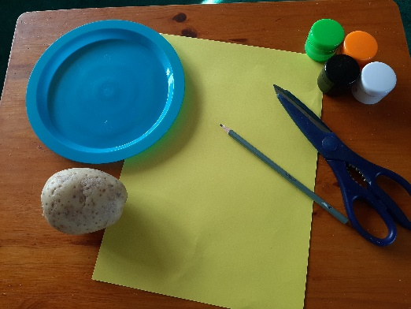
A paper plate or a piece of thick paper big enough to draw round a plate, plus the plate
A potato
Paints – acrylic are best
Paintbrush
Scissors if you are making a plate template
A small sharp knife

First:

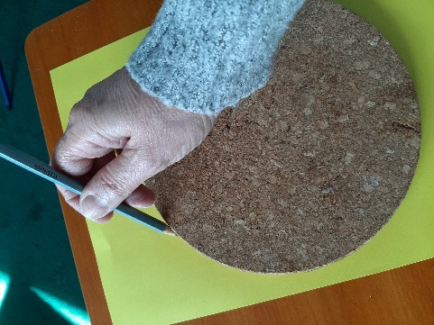
If you are using paper, draw round a plate or other round object that fits your page. Carefully cut it out.

Next:

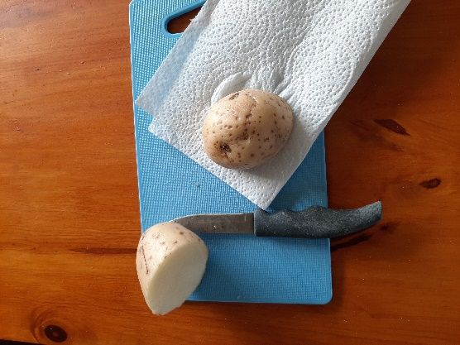
Ask a grown up to help with this bit.

Cut your potato in half and dry it off with a piece of kitchen paper.

Decide on the pattern you would like to have on your plate and mark it onto one half of your potato. You can do this with pencil or pen.

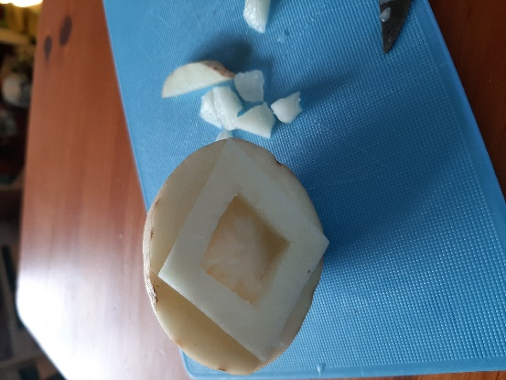
Ask your helper to cut away the extra bits of potato so only your design stands out. It’s easier if you stick to a simple design. Your design should be about 3-4mm clear of the rest of the potato surface.

Then:

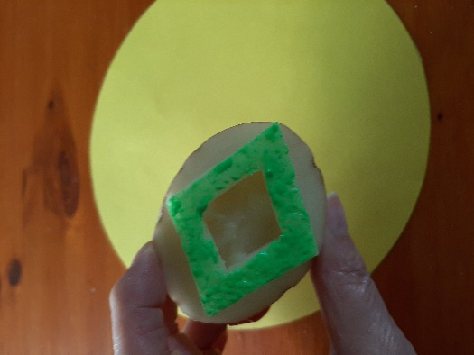
Using the paintbrush, put a layer of paint onto your design. Don’t make it too thick or you won’t get a clear print. You might want to practise on a spare piece of paper first.

When you are ready, decide where your pattern is going on your plate – will it be round the edges or in the middle?

Gently put the painted side of the potato down on your plate and press down. Lift it off again carefully so you don’t smudge your print.
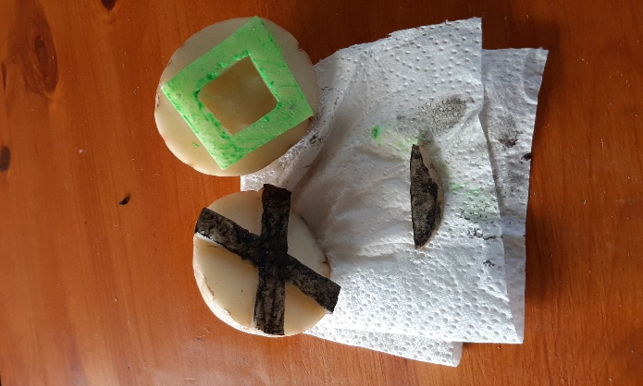
Remember you can use the other half of your potato to add a different design and a different colour. You can even use the bits you cut off.

If you want to use the same pattern again in a different colour, just wash the surface of the potato and dry it again before applying your new colour of paint.

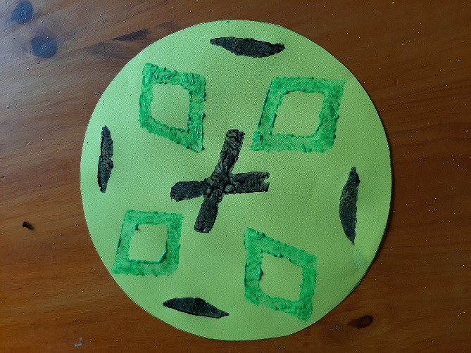
And now you have your own plate!

Suggestions:
You can print with lots of things. Why not try using different vegetables or things you can find lying round your house? What about a bottle top or one of your toys? Bits of cardboard or polystyrene packaging will also work and you can cut your own shapes into them.

Now you’ve got the hang of printing your plate, why not see if you can copy one of the ones in our photos?

Whatever you make, have fun, and DON’T EAT THE POTATO AFTERWARDS!
This Photo by Unknown Author is licensed under CC BY-NC-ND

