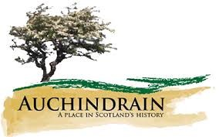
Can you unscramble all these words connected to Auchindrain? Look at our online interactive guide if you need help.

Auchindrain
1. YLLGRA ____________________________________________
2. IAARUCHDINN _______________________________________
3. NRAB ______________________________________________
4. LBAE PLLO _________________________________________
5. NCHALKOBTR ________________________________________
6. MPACBOW ___________________________________________
7. ALCTET ____________________________________________
8. DERVSOR ___________________________________________
9. EDEID _____________________________________________
10. OHTYSIR ___________________________________________
11. SHUOES ____________________________________________
12. AALDYERK __________________________________________
13. ARMINT ____________________________________________
14. CLLMCUAM __________________________________________
15. NMURO _____________________________________________
16. HEESP _____________________________________________
17. SONTE _____________________________________________
18. NOESTR ____________________________________________
19. TTHHAC ____________________________________________
20. IEHHTGNRS _________________________________________
21. TSOWHIPN __________________________________________
22. ORRTACT ___________________________________________
23. SLLRERAEVT ________________________________________
24. WESHHITWA _________________________________________

