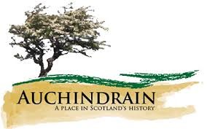
Auchindrain
You can use our online interactive guide to help you with the answers.
 |  |  |  |  |  |  |  |  |  |  |  |  |  |  |  |  |  |  | 1
 |  |  |  |  |  |  |  |  |  |  |  | 2
 |  |  |  |  |  |  |  | 3
 |  |  |  |  |  |  |  | 4 |  | 5 |  |  |  | 6 |  |  | 7
 | 8 |  |  |  |  |  | 9 |  |  |  |  |  |  | 10
 |  |  |  |  |  | 11
 |  |  |  | 12 |  |  |  |  |  |  |  |  |  | 13
14

Across  3. The only flowers grown in a garden here  9. Only one house now has this type of roofing  10. You will find us in this county in the west of Scotland  12. You would have grown your vegetables here  13. Three McCallum gentlemen shared this name  14. The New House is covered in these | Down  1. Ian and Flora's Uncle Neil  2. Auchindrain is not a village, it's a _______________  4. The large rainwater barrel originally contained this liquid  5. Duncan Munro's nickname  6. Drovers collected these once a year for market  7. The word used to describe where the animals slept  8. The plant our name comes from  11. Beal Poll was the township's ______ woman

