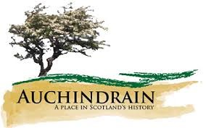
Auchindrain
Match the clues with the correct answer. Our online interactive guide will help.

1. Drovers collected them once a year for market | A. Whisky
2. Duncan Munro's nickname | B. Blackthorn
3. Beal Poll was the township's ______ woman | C. Daffodils
4. The plant our name comes from | D. Cattle
5. Auchindrain is not a village, it's a _______________ | E. Thatch
6. You will find us in this county in the west of Scotland | F. Gaelic
7. Three McCallum gentlemen shared this name | G. Longhouses
8. You would have grown your vegetables here | H. Eddie
9. Ian and Flora's Uncle Neil | I. Range
10. The New House is covered in these | J. Threshing
11. The only flowers grown in a garden here | K. Slate
12. Only one house now has this type of roofing | L. Stoner
13. The word used to describe where the animals slept | M. Kailyard
14. The large rainwater barrel originally contained this liquid | N. McPhail
15. Our hens have this kind of roof on their house | O. Byre
16. Only Eddie's house and the New House had this | P. Shingles
17. The name for the open fire type of cooker | Q. Township
18. There are three of these bigger houses in the township | R. Argyll
19. The language originally spoken in Auchindrain | S. Running water
20. The barns with two opposing doors were used for this | T. Wise

